Practicing Cryptography with CyberChef- Submission Template
This document only lists the questions and does not have the encrypted messages, hashes etc. In order to access the complete project details, please refer to the Project Brief document.

Task 1 (Points: 9)
- Question 1: Is the hash value provided by Bob an exact match to the hash value of the file.docx document? Submit the screenshot of the MD5 hash value generated using CyberChef.
Answer 1:

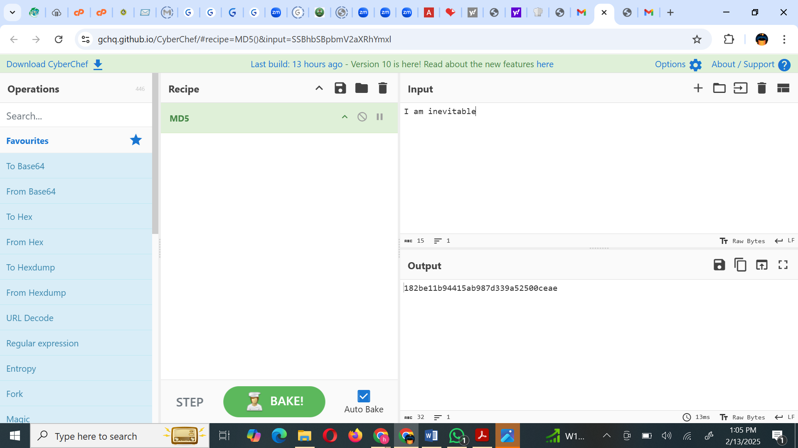
Question 2: If the hash values are an exact match, what does it signify? (what is the significance of the hash value in this scenario)
Answer 2: it signifies that the file has not been altered or tampered with. In this scenario, the MD5 hash serves as a unique digital fingerprint of the file.docx document. Since the computed hash matches the one provided by Bob, it confirms that the file remains unchanged, ensuring its integrity, authenticity, and reliability.

- Question 3: What is the Message inside the document- file.docx? Submit the screenshot of the password determined on CyberChef.
Answer 3:

- 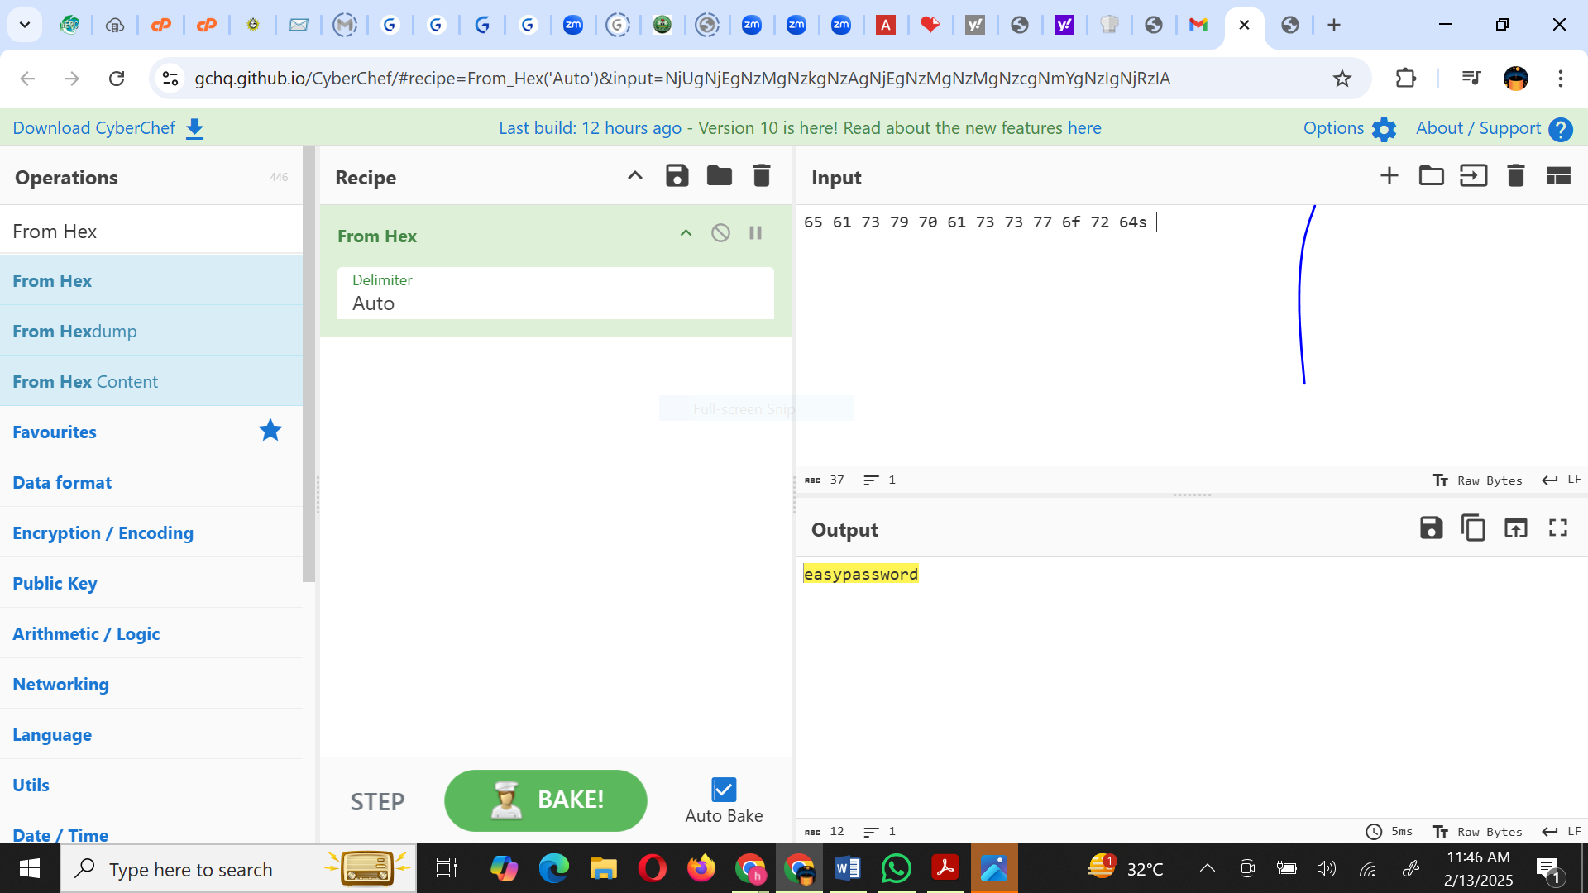

Task 2 (Points: 8)
- Question 1: For the hash – 02e85269abc0328647f5b8c3bacb7231, answer the following. Submit the screenshot of the output of the operation performed on Cyberchef to determine the below details.
  - What is the Hash length?
  - List all hash functions which could have been used to generate the hash.
Answer 1: 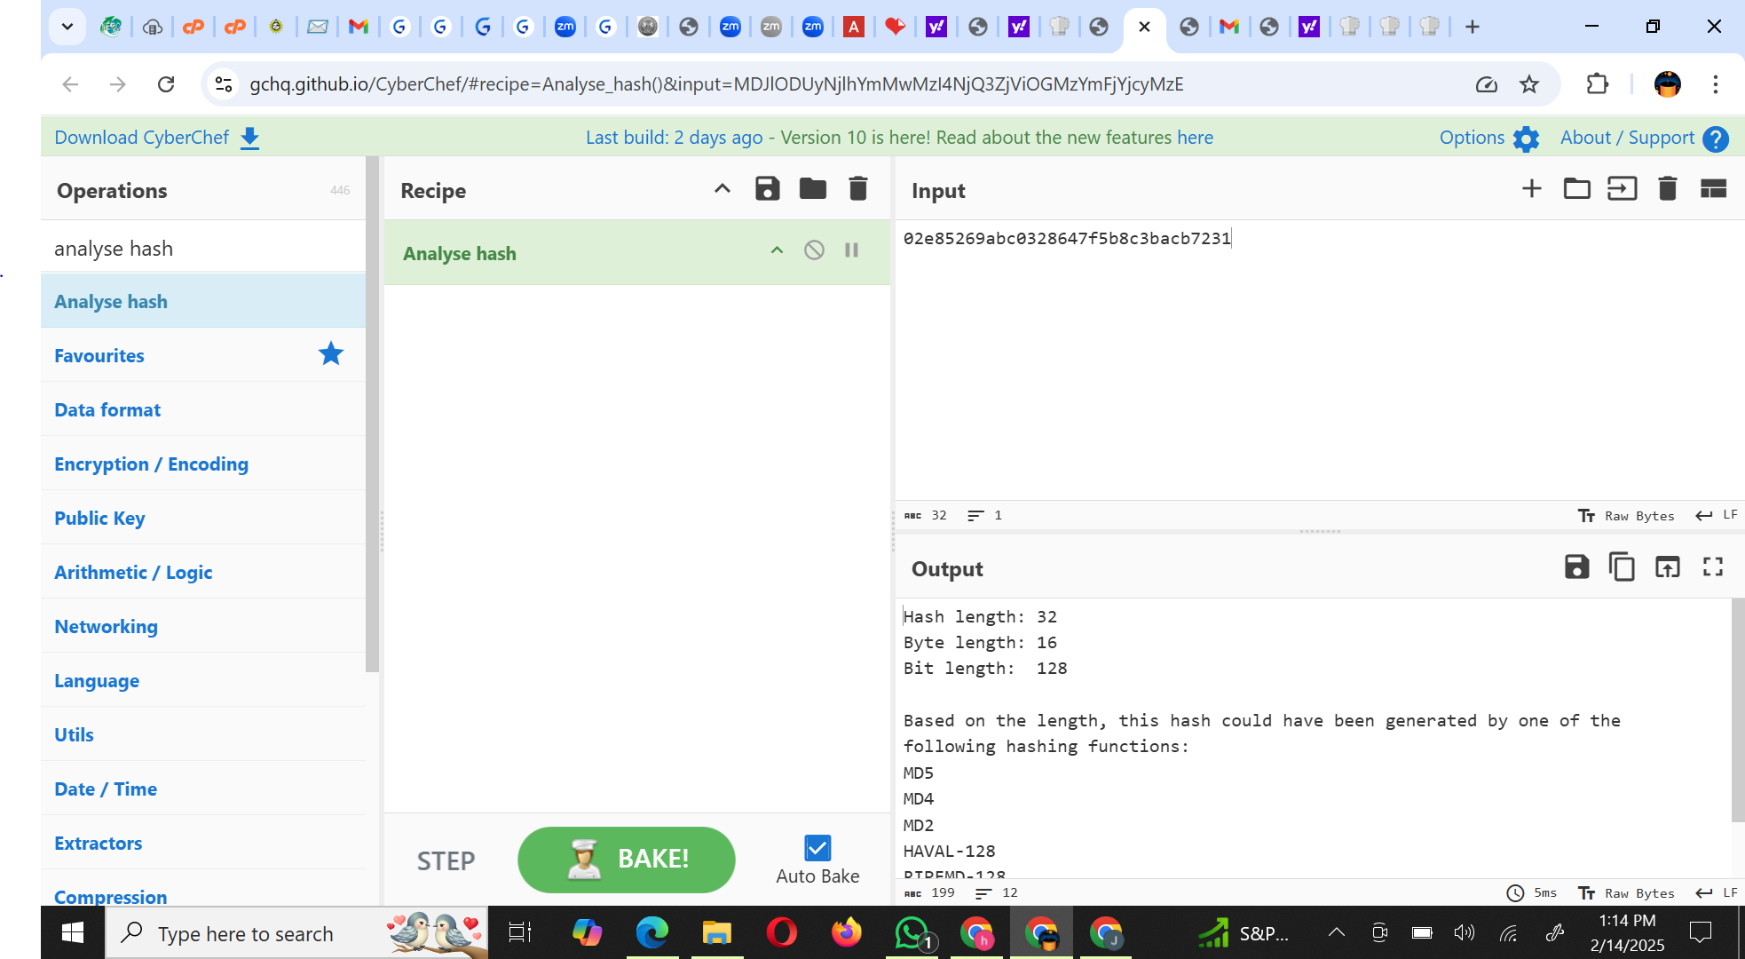

- Question 2: For the hash – 8fc6c02950559044cc4c71ae7b8778583798c203, answer the following. Submit the screenshot of the output of the operation performed on Cyberchef to determine the below details.
  - What is the Hash length?
  - List all hash functions which could have been used to generate the hash.
Answer 2:
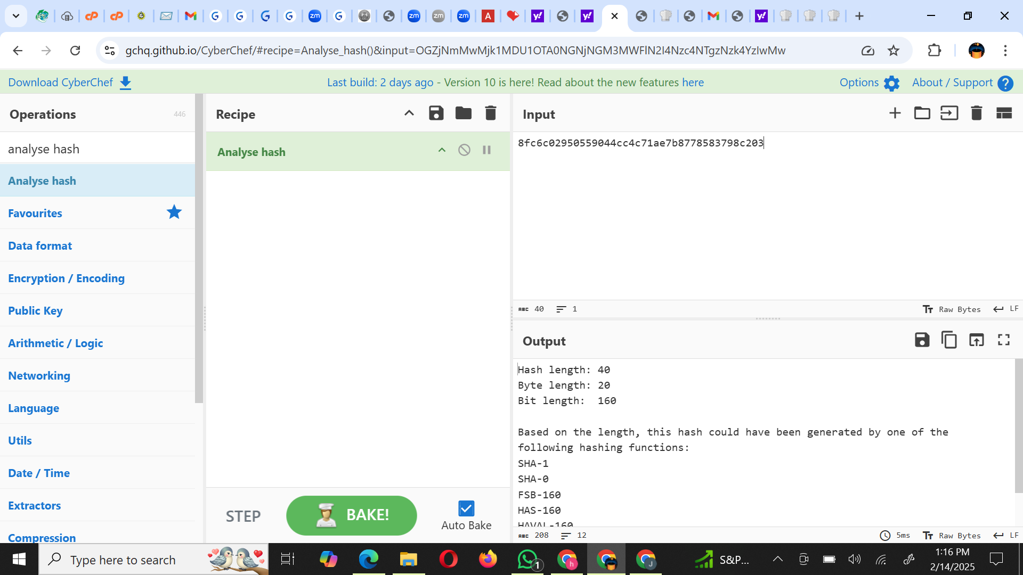

Task 3 (Points: 8)
- Question 1: Which Logical operation is the security team using to encrypt the communication? [Use the quote- “The outputs are true only when the number of true inputs is odd"]
Answer 1: XOR (exclusive OR) OPERATIONS
- Question 2: What is the key used in these encrypted communications? Submit the screenshot from CyberChef tool of the decoded URL for https%3A%2F%2Fgithub%2Ecom%2F.
Answer 2:
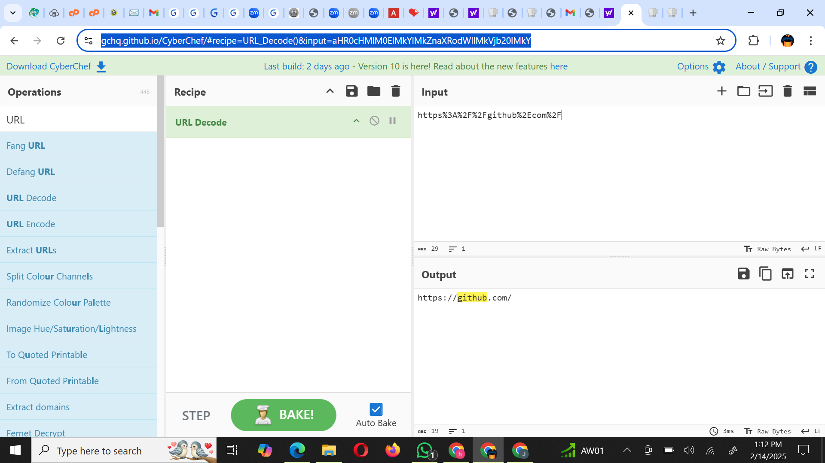

- Question 3: What is the task you have to perform (as per the email)? Submit the screenshot from CyberChef of the decoded message, ensure that the operation used (recipe section) and the output is visible in the screenshot.
Answer 3:
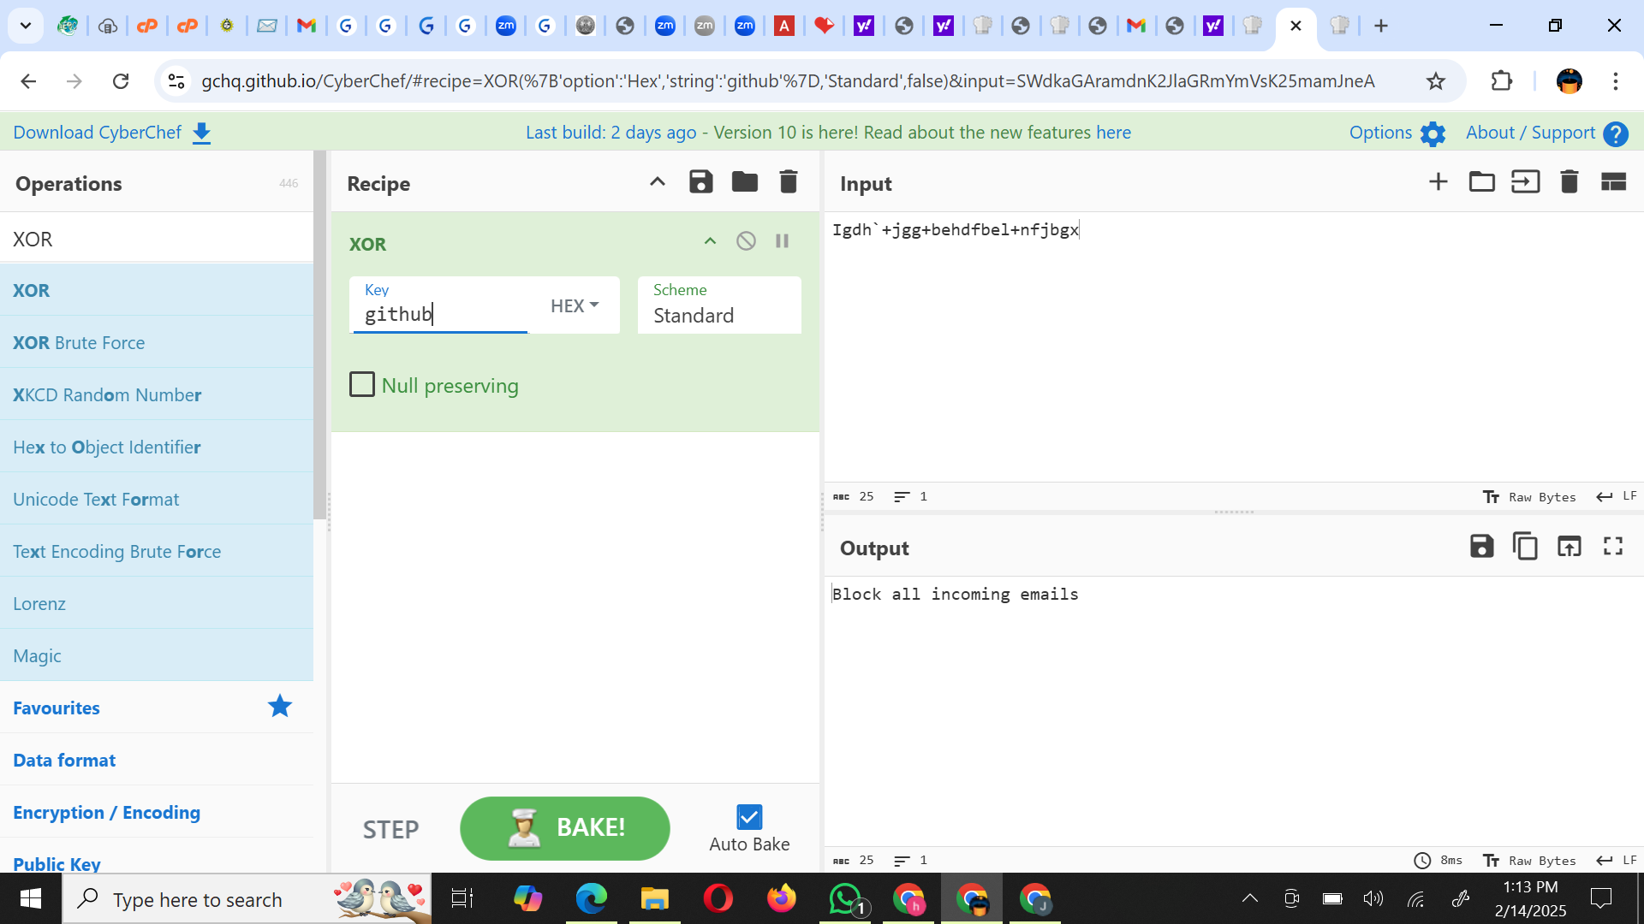
- Question 4: What form of encryption is being used in this scenario – Symmetric or Asymmetric Encryption. Explain.
Answer 4:
- The encryption being used in this scenario is symmetric encryption because the same key is used for both encryption and decryption.
- Explanation
Symmetric Encryption:
This method uses a single secret key for both encrypting and decrypting the data.
If the same key is used in both processes, it confirms the use of symmetric encryption.

Asymmetric Encryption:
In contrast, asymmetric encryption uses a pair of keys (a public key for encryption and a private key for decryption).
Since your scenario states that the same key is being used, it does not fit the asymmetric model.

Task 4 (Points: 5)
- Question: What is the hidden message? Submit the screenshot from the CyberChef tool ensuring that the output (the message) and the operation performed (recipe section) is clearly visible.
Answer:
